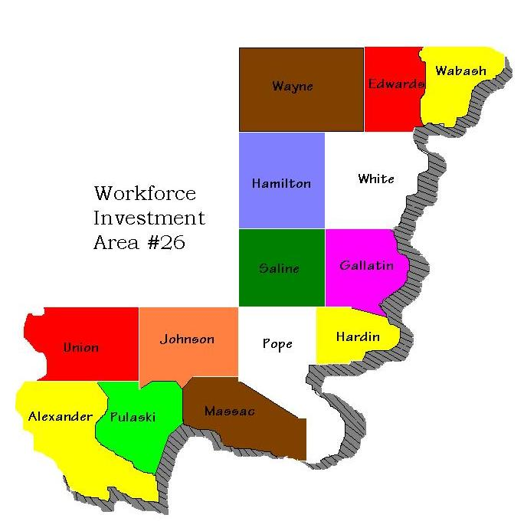

Southern 14 Workforce Investment Board Inc.

REQUEST FOR PROPOSAL
FOR INFORMATION TECHNOLOGY

For the Period of
July 1, 2025 thru June 30, 2026

INQUIRIES AND PROPOSALS SHOULD BE DIRECTED TO:
Pamela Barbee
Executive Director
Southern 14 Workforce Investment Board, Inc.
P.O. Box 186
Carmi, Illinois 62821
Phone: (618)382-5024
Fax: (618)382-7038
Email: pbarbee@so14lwib.com

Proposal Guidelines
Table of Contents
 |  |  |  |  |  |  |  | Page Number
I | General Information
 | A |  |  | Purpose |  |  |  | 3
 | B. |  | Who May Respond |  |  |  |  | 3
 | C |  |  | Bidders Conference |  |  |  | 3
 | D |  |  | Instructions on Proposal Submission
 |  |  |  | 1 |  | Closing Submission Date |  | 3
 |  |  |  | 2 |  | Inquires |  | 3
 |  |  |  | 3 |  | Conditions of Proposal |  | 3
 |  |  |  | 4 |  | Instructions for Prospective Contractors |  | 4
 |  |  |  | 5 |  | Right to Reject |  | 4
 |  |  |  | 6 |  | Small and/or Minority Owned Businesses |  | 4
 |  |  |  | 7 |  | Notification of Award |  | 5
 | E |  |  | Description of Entity |  |  |  | 5
 | F |  |  | Options |  |  |  | 5
II | Specific Schedule
 | A |  |  | Delivery Schedule |  |  |  | 6
 | B |  |  | Price |  |  |  | 6
 | C |  |  | Payment |  |  |  | 6
 | D |  |  | Confidentiality |  |  |  | 6
 | E |  |  | Budget |  |  |  | 6
III | Offertory's Technical Qualifications
 | A |  |  | Prior Audit Experience |  |  |  | 6
 | B. |  | Organizations, Size, and Structure |  |  |  |  | 7
IV | Proposal Evaluation
 | A |  |  | Submission of Proposals |  |  |  | 7
 | B. |  | Non-responsive Proposals |  |  |  |  | 7
 | C |  |  | Review Process |  |  |  | 7
 | D |  |  | Evaluation Criteria |  |  |  | 8
V | Attachments
 | A |  |  | Certifications |  |  |  | 9

I. GENERAL INFORMATION

A. Purpose

This Request for Proposal (RFP) is to contract for Information Technology services for the initial period of July 1, 2025, through June 30, 2026. At the discretion of the Southern 14 Workforce Investment Board, the Information Technology contract may begin as of the date of the award and be extended for three optional one-year periods.

B. Who May Respond

RFP is open to any individual, business, or not-for-profit demonstrating the ability and capacity to provide requested services.

C. Bidder's Conference
A bidders conference will not be held for this RFP. All questions should be submitted to boffice@so14lwib.com Q&A will be posted on the Southern 14 website at www.so14lwib.com.

Additionally, prospective bidders may schedule a visit to the Southern 14 Office to review our equipment and assess our needs prior to submission of the proposal. To schedule an office visit contact Southern 14 at the email listed above or phone 618 382 5024.

- Instructions on Proposal Submission

1. Closing Submission Date
Proposals must be received at the offices of the Southern 14 Workforce Investment Board, Inc. no later than 4:00 p.m. on February 28, 2025

2. Inquiries
Inquiries concerning this RFP should be directed to Pamela Barbee at: Southern 14 Workforce Investment Board (618) 382-5024 - pbarbee@so14lwib.com

3. Conditions of Proposal
All costs incurred in the preparation of a proposal responding to this RFP will be the responsibility of the Offeror and will not be reimbursed by Southern 14 Workforce Investment Board.

- Instructions to Prospective Contractors

Your proposal should be addressed as follows:

Name: Pamela Barbee
Title: Executive Coordinator / Chief Financial Officer
Entity: Southern 14 Workforce Investment Board
Address: P. O. Box 186
Carmi.Illinois 62821

It is important that the Offeror's proposal be submitted in a sealed envelope clearly marked in the lower left-hand corner with the following information.

SEALED PROPOSAL FOR INFORMATION TECHNOLOGY SERVICES

Failure to do so may result in premature disclosure of your proposal.

It is the responsibility of the Offeror to ensure that the proposal is received by the Southern 14 Workforce Investment Board by the date and time specified above. Late proposals will not be considered.

- Right to Reject

Southern 14 Workforce Investment Board reserves the right to reject any and all proposals received in response to this RFP. A contract for the accepted proposal will be based upon the factors described in this RFP.

6. Small and/or Minority-Owned Businesses

Efforts will be made by the Southern 14 Workforce Investment Board to utilize small businesses and minority-owned businesses.

An Offeror qualifies as a small business firm, if it meets the definition of "small business" as established by the Small Business Administration (13 CFR 121.201), by having average annual receipts for the last three fiscal years of less than six million dollars.

- Notification of Award

It is expected that the successful firm will be named within 3 weeks of the closing date for the receipt of proposals. Notification of the name of the successful firm will be provided to respondents on request. It is expected that the contract shall be a one-year fixed-price contract with an option for three additional one-year periods. Costs for subsequent years will be negotiated prior to the start of each optional period.

- Description of Entity and Services To Be Provided

The Southern 14 Workforce Investment Board is a nonprofit organization which serves 14 counties in Illinois. Southern 14 Workforce Investment Board is a private, nonprofit corporation and has been determined to be exempt from Federal income tax under Section 501(c)(3) of the Internal Revenue Code. It is governed by a 34-member volunteer Board of Directors. Administrative offices and all records are located at 304 East Robinson Street - Suite 210, Carmi, Illinois 62821.

It is expected the Information Technology contract will provide network and technical support and maintenance to the Southern 14 Board office to ensure that the technology, both hardware and software, runs smoothly and safely in the day-to-day operations. Services may include, but are not limited to network security, remote and on-site repairs, maintenance, off-site backup of data, software updates, equipment evaluation, and recommendations.

- Options

At the discretion of the Southern 14 Workforce Investment Board the Information Technology contract may be extended for three optional one-year periods. Costs for subsequent years will be negotiated with the firm prior to the start of each optional period. It is anticipated that the cost for the optional years will be based upon the actual cost and time expended by the firm in the precious year. Notice of intent to exercise the next option shall be submitted in writing, with any cost increase or decrease included, to the office of the Southern 14 Workforce Investment Board within 90 days of completion of the current contract.

II. SPECIFICATION SCHEDULE

A. Delivery Schedule

Maintenance and repair will be provided as needed with work performed during regular business hours in a way that avoids disruption of day-to-day operations. Services may be performed either on-site or remotely at the discretion of the firm. It is expected that the firm will respond to service requests, by some means, within three hours of the request.

B. Price

The Offeror's proposed price should be submitted separately. Include information indicating the proposed monthly or annual cost of the Information Technology contract, as well as a quote for any initial proposed equipment or software required.

C. Payment
It is expected that this will be a fixed-priced monthly contract for maintenance and repair with the firm submitting an invoice to Southern 14 by the 15th day of the month.

D. Confidentiality

The Offeror agrees to keep the information related to all data in strict confidence. Other than the reports submitted to the Southern 14 Workforce Investment Board, the Offeror agrees not to publish, reproduce, or otherwise divulge such information in whole or in part, in any manner or form or authorize or permit others to do so, taking such reasonable measures as are necessary to restrict access to the information, while in the Offeror's possession, to these employees on the Offeror's staff who must have the information on a "need-to-know" basis. The Offeror agrees to immediately notify, in writing, the Southern 14 Workforce Investment Board's authorized representative in the event the Offeror determines or has reason to suspect a breach of this requirement.

E. Budget

It is expected that the budget of this contract will not exceed $20,000 annually.

III. OFFEROR’S TECHNICAL QUALIFICATIONS

The Offeror, in its proposal, shall, as a minimum, include the following:

A. Prior Experience

The Offeror should describe its prior experience including the names, addresses, contact persons, and telephone numbers of organizations served.

B. Organization, Size, and Structure

The Offeror should describe its organization, size, and structure. Indicate, if appropriate, if the firm is a small or minority-owned business.

IV. PROPOSAL EVALUATION

A. Submission of Proposals

All proposals shall include a detailed description of services to be provided and the method of providing those services, as well as, pricing information (in a separately sealed envelope), including a quote of initial hardware and software required and the signed certification included in the RFP.

B. Non-responsive Proposals

Proposals may be judged non-responsive and removed from further consideration if any of the following occur:

1 . The proposal is not received timely in accordance with the terms of this RFP.
2. The proposal does not follow the specified format.

C. Review Process

The Southern 14 Workforce Investment Board may, at its discretion, request presentations by or meetings with any or all Offerors, to clarify or negotiate modifications to the Offerors' proposals.

However, Southern 14 Workforce Investment Board reserves the right to make an award without further discussion of the proposals submitted. Therefore, proposals should be submitted initially on the most favorable terms, from both technical and price standpoints, which the Offeror can propose.

Southern 14 Workforce Investment Board contemplates the award of the contract to the responsible Offeror with the highest total points.

D. EvaluationCreiteria

Evaluation of each proposal will be based on the following criteria:

Factors |  |  | Point Range
1 | Prior experience providing information technology services |  | 6 Max.
 | a. | Services to Not-For-Profits | 0-3
 | b. | Services to Organizations with Grant Connection to State or Federal Government | 0-3
The Southern 14 Workforce Investment Board will contact prior organizations to verify the experience provided by the Offeror.
2 | Organization, size, and structure of the Offerors firm. |  | 4 Max.
 | a. | Adequate size of the firm | 0 – 2
 | b. | Minority/small business | 0 – 2
3 | Offeror's understanding of work to be performed. |  | 80 Max.
 | a. | Adequate size of organization to provide coverage | 0-10
 | b. | Estimated Response Time | 0-10
 | c. | Conducted On-Site Review Prior to Proposal | 0-20
 | d. | Description of Method of Response On-site or Remotely | 0-20
 | e. | Detailed Description Services to Provide | 0-20
4 | Price |  | 10 Max.
 | a. | Monthly or Annual Fixed Price | 0-5
 | b. | Quote of Initial Hardware and Software Required for Contract | 0-5
 |  | Total Maximum Points | 100

CERTIFICATIONS

On behalf of the Offeror:

- The individual signing certifies that he/she is authorized to contract on behalf of the Offeror.

- The individual signing certifies that the Offeror is not involved in any agreement to pay money or other consideration for the execution of this agreement, other than to an employee of the Offeror.

- The individual signing certifies that the prices in this proposal have been arrived at independently, without consultation, communication, or agreement, for the purpose of restricting competition.

- The individual signing certifies that the prices quoted in this proposal have not been knowingly disclosed by the Offeror prior to an award to any other Offeror or potential Offeror.

- The individual signing certifies that there has been no attempt by the Offeror to discourage any potential Offeror from submitting a proposal.

- The individual signing certifies that he/she has read and understands all of the information in this Request for Proposal.

Dated this __________day of_________________________________________ ,20_____.

____________________________________________
(Offeror's Firm Name)

____________________________________________
(Address)

____________________________________________
(Address)

____________________________________________
(Signature of Offeror's Representative)

___________________________________________

(Printed Name and Title of Individual Sign

